The weather Site Project

Website Planning Document

Veronica Jacobs

CIT 230

# Site Name

Name: “What to Wear Weather”

Proposed domain: “whattowearweather.com”

Available: yes

Cost: $12/year.

# Site Purpose

The purpose of the site is to suggest what you should wear that day based on the weather.

Client’s functional specifications: Should display the day’s weather, suggest appropriate clothing, show full example outfits, be able to choose other cities, and links to sites where you can buy weather appropriate clothing.

The industry: Clothing industry, weather industry

Viable goals: Provide information to users about what to wear in todays weather.

Perceived content objectives: The day’s weather report so the user knows if it is going to windy or cold or rainy. Outfit suggestions so the user can choose weather appropriate clothing. Links to sites where the user can buy weather appropriate clothing. The user may not have appropriate clothing and will need it for future days with similar weather. A 10-day forecast so the user can plan ahead. Other cities in case the user is traveling. Forum to report weather so the users can talk to one another and relay important real-time information.

Services provided: Weather information, 10-day forecast, weather appropriate outfit suggestions, links to external sites where the user can buy weather appropriate clothing, a forum to report weather.

# Target Audience and Scenarios

## Audience

Who: Mostly women, people who are leaving their homes to run errands or go to work or school, fashionistas, mothers with young children, savvy dressing guys, anyone who wants to dress appropriately for the weather.

Age: 14 to 100

Income: $40,000 and above annually

Education: All levels. Students, college graduates, mostly bachelors-level

Experience with the topic: They have used other weather sites in the past.

Family status: All. Single, married, married with kids

Where will the user be accessing the site: From their homes

When will the user be accessing the site: In the morning, before they leave for work, school, or to run errands.

How will the user be accessing the site: Mostly from a mobile phone, a few from tablets, and even fewer from desktops.

User’s motivation for visiting the site: They want to know what clothes would be appropriate for the day’s weather.

Personas

### Sally Smith



Occupation: Stay-at-home mom

Demographics and Education: 28 years old, married, mother of 2, has some college education.

Goals and motivation for using the site: She is leaving the house with her children to go to the grocery store and wants to know what she and her children should wear.

Environment: She lives in a small house in the suburbs. Most of her friends are other young moms. She is comfortable using a smart phone. She uses social media extensively to keep in touch with family who lives far away and get parenting tips. She used to be pretty active, these days she chases a toddler around.

Quote: “Motherhood is the greatest thing and the hardest thing.”

### Ryan Dodd



Occupation: Senior Business Operations Program Manager at a big tech company

Demographics and Education: 35 years old, single, has a BA in Communications/Public Relations

Goals and motivation for using the site: He is a savvy dresser, likes fashion. He wants to know if the weather will be nice and if he can wear his new shoes today.

Environment: He lives alone in a nice apartment in a big city. He enjoys going out on the town with his other single friends. He is very comfortable with technology. He is a proud Apple user. His career is very important to him. He plays in a local soccer league on the weekends.

Quote: “Self-belief and hard work will always earn you success.”

Scenarios

What is the weather today?

How cold is its, will I need a jacket or a coat?

Will I need a jacket later tonight, after it gets dark?

Is it going to be wet, should I wear my rain boots?

Can I wear my new shoes or is it going to rain or snow?

I’m going to the park today, what should I wear?

What kind of clothes should I pack for my vacation?

I know I will be warm enough in this outfit, but will my baby?

Will I need an umbrella today?

Do I need to buy a running jacket for the race this weekend?

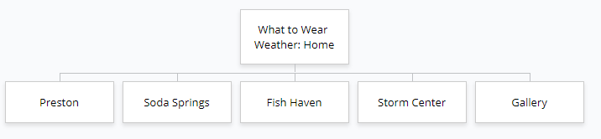Site Map

# Color Scheme

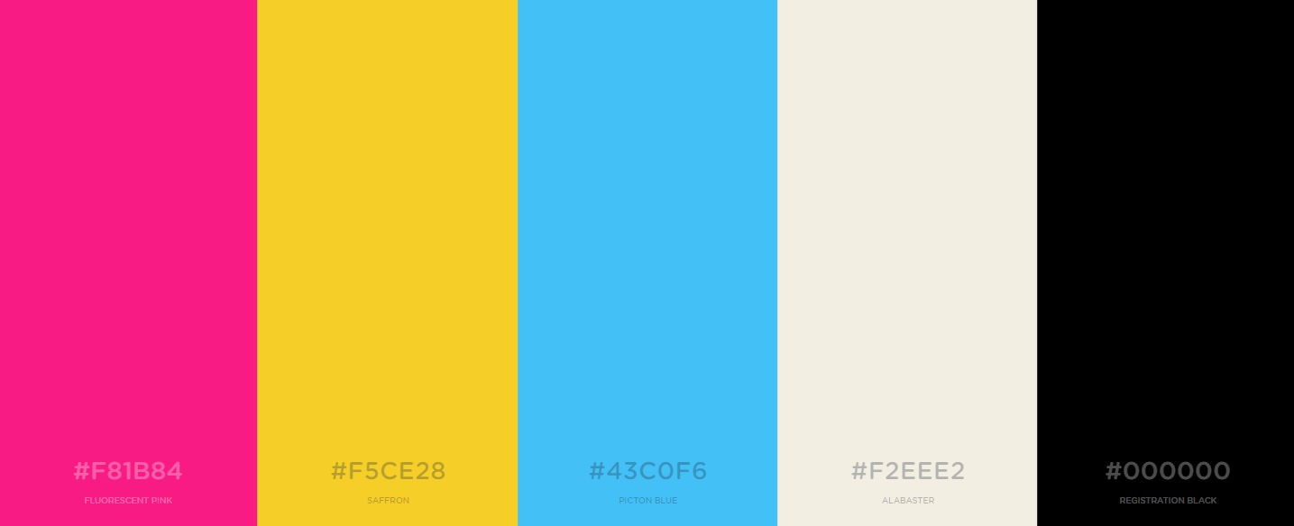

A picture containing screenshot

Description generated with very high confidenceThe background of my site will be Alabaster. The majority of the text will be Registration Black. Headings against colored backgrounds will be Alabaster. The header and the footer will be Picton Blue. The nav bar will be Saffron. The snap shot of current conditions and weather summary will have Fluorescent Pink background. The body of my site will alternate between Saffron and Fluorescent Pink. If the body copy is hard to read, I will make the background Alabaster and the frame Saffron or Fluorescent Pink.

###### Figure 1: Mockup of Site with Colors

# Typography

Headings: Vidaloka



I chose this font because it looks like a font that would be used for the title of a fashion magazine.

Body copy: Open Sans



I chose this font because it contrasts well with Vidaloka and it is easy to read.

Code to embed fonts into HTML:

<link href="https://fonts.googleapis.com/css?family=Open+Sans|Vidaloka" rel="stylesheet">

CSS rules to specify these families:

font-family: 'Vidaloka', serif;

font-family: 'Open Sans', sans-serif;

Sample:



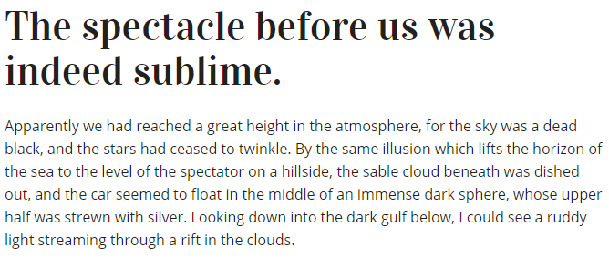

# Wireframe Sketches

A screenshot of a video game

Description generated with high confidence

A screenshot of a cell phone

Description generated with very high confidenceA screenshot of a computer

Description generated with very high confidence